**The Project: Web Platform for Client-Supplier Business Management**

**Role:** Supplier part website

**Development Tools:**

Front-end Development: Vue framework (run Vue and “npm install” in terminal to add package)

Back-end Development: Django 2.7 framework

**How to start:**

**Front-end website on the AWS server:**

1. Enter “http://3.135.198.81:85/#/” in the URL of the browser to open the web page.

**Back-end website on the AWS server:**

1. Open <http://3.135.198.81:8888/026b9e47> which is an admin website of the database in any browser and login with *username: kkrwfatb* and *password: 5a9796ac*

2. Use terminal ec2-user@ip-172-31-2-121 and *cd* to the project root which is */www/wwwroot/myproject3888/*

3. Use *kill -9 `lsof -t -i:8081`* to stop current running website and use *./start.sh* to start a new one

4. [*http://3.135.198.81:8081/*](http://3.135.198.81:8081/)

# This is the html of the database but it only carries the database since the UI is on the local host

**Instruction:**

1. Go to “<http://3.135.198.81:85/#/>”
2. Click on “Sign Up” button to create an account
3. Click on “Log in” button

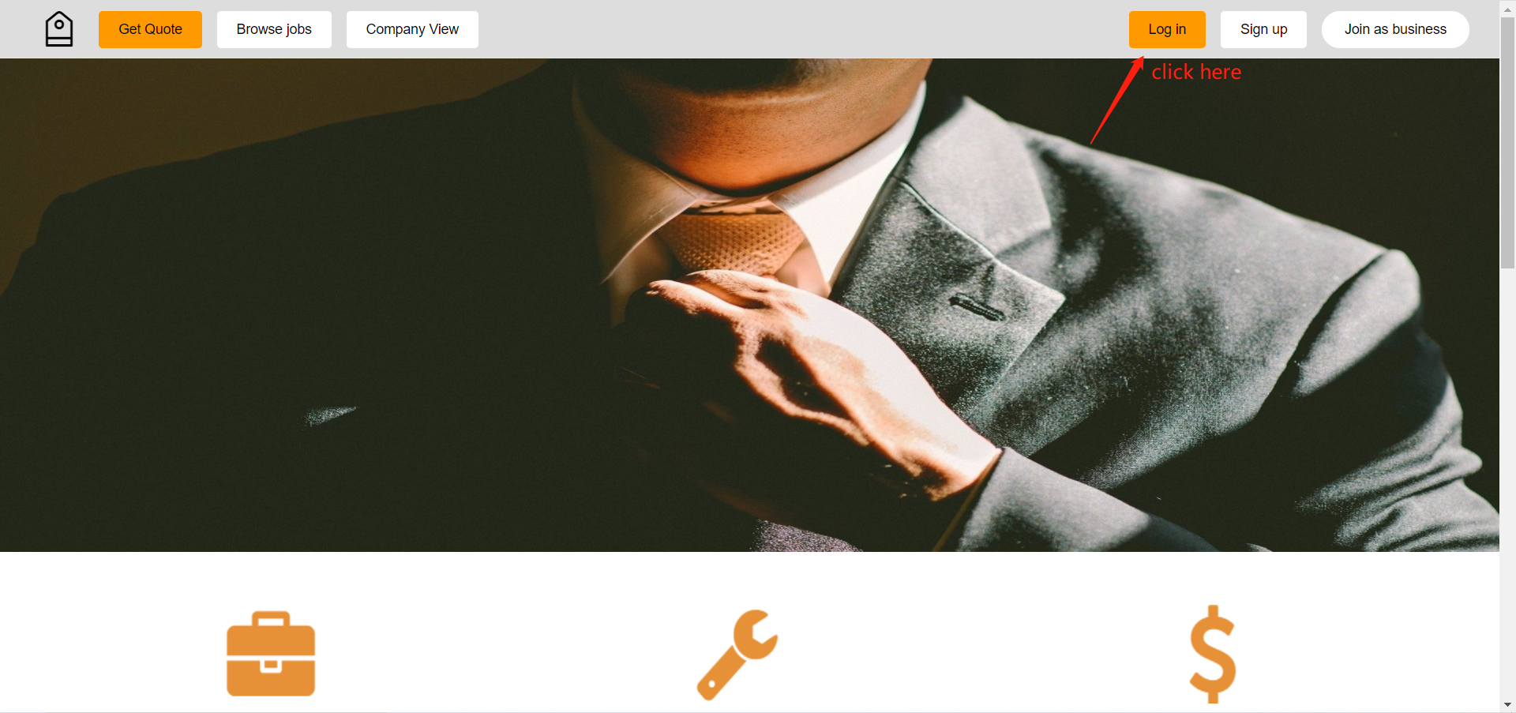

1. type in email and password:

* email:[isys3888@gmail.com](mailto:isys3888@gmail.com)
* password:isys3888

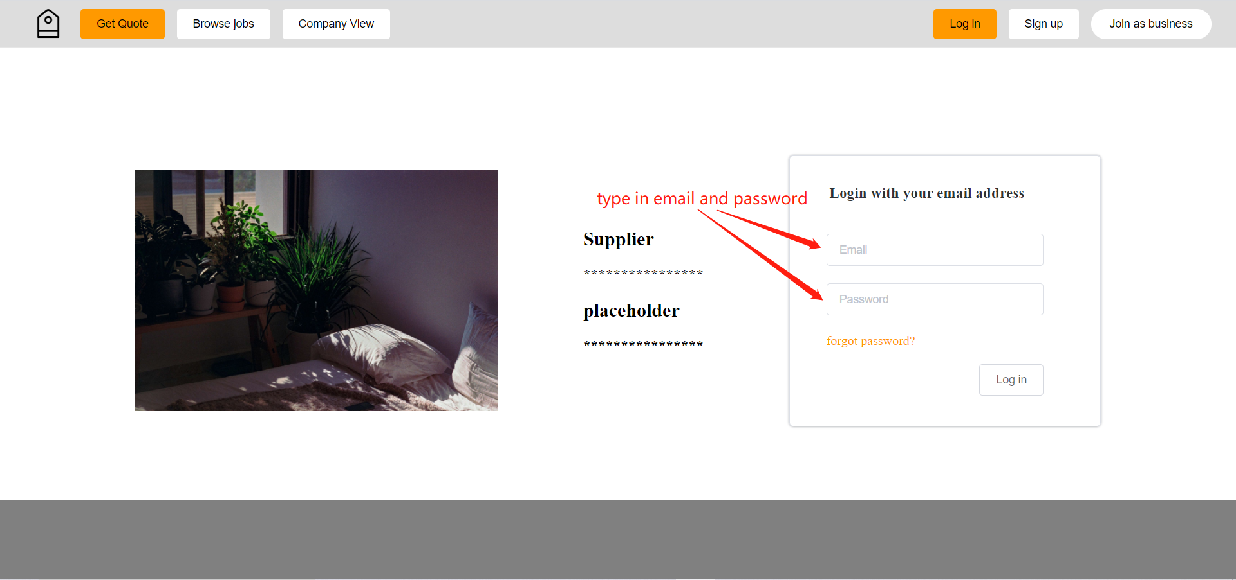

1. After successfully login, the user gets into the supplier homepage where all main functions can be accessed by utilizing shortcuts provided by the side navigation bar and dropdown menu. Detailed information is elaborated in the final report.

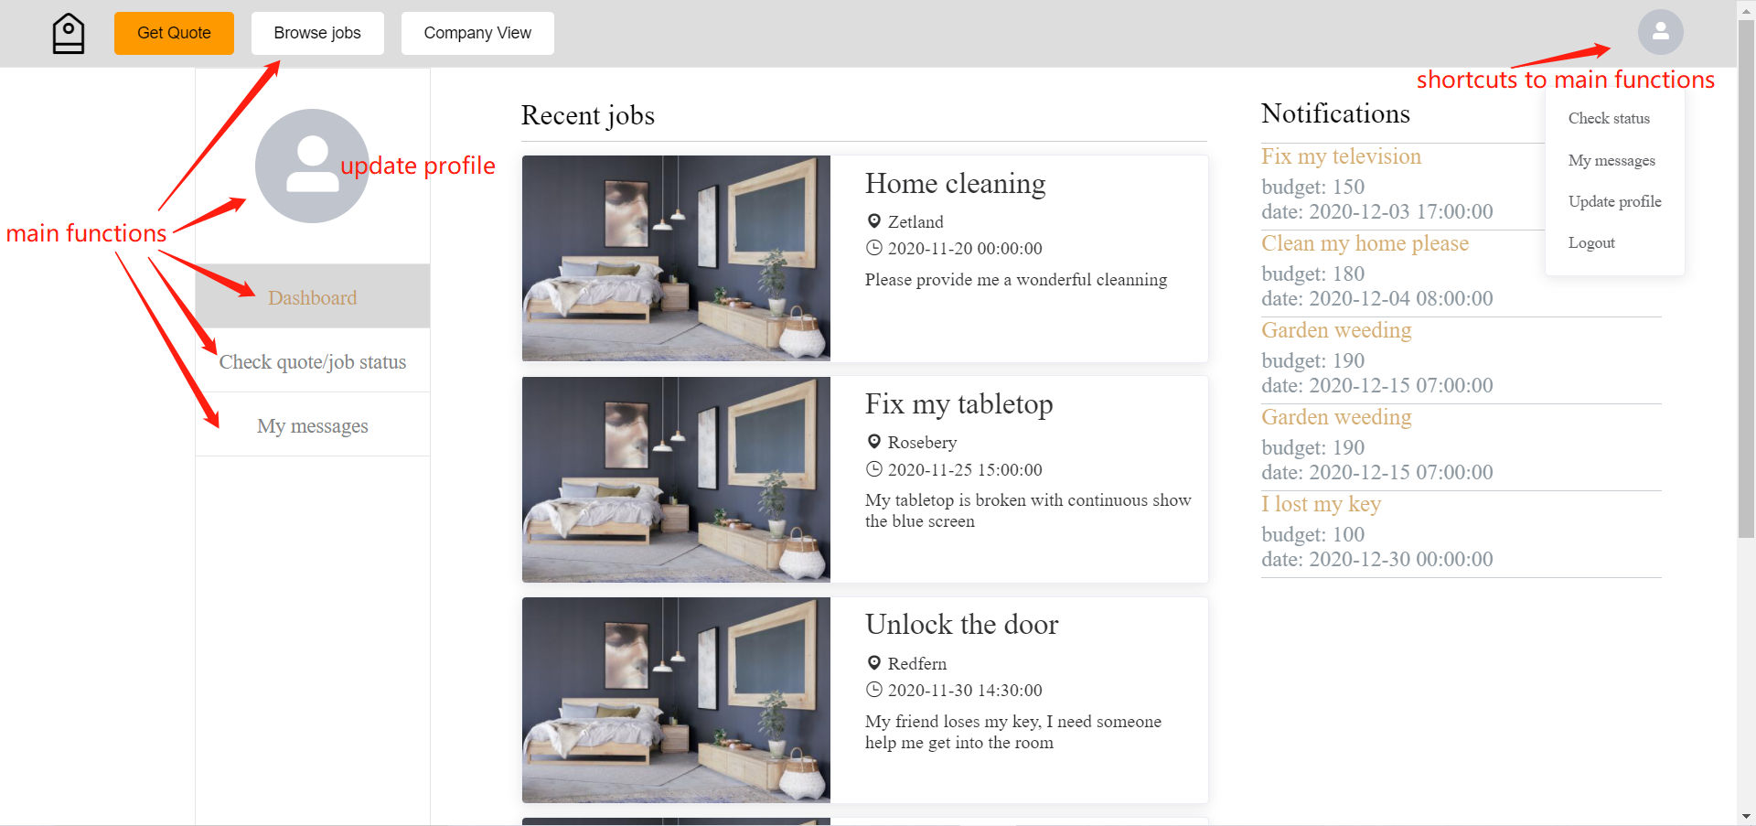

1. The user can also register a new account by clicking on the “Sign up” button and type in email and password.

